Supporting: MSFKB3006 Install fitted cabinets and components

Section 3 Assignment: Installing appliances
Name |  | Date

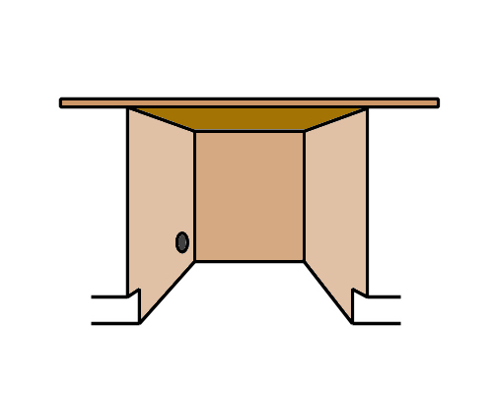
Question 1
You have been asked to build in a space for a dishwasher between the sink cabinet and the cutlery drawers. The dishwasher dimensions are:
Width: 590 mm
Height: 850 mm (minimum height, with adjustable legs screwed in)
- You decide to allow a clearance of 5 mm on each side of the dishwasher.
What will the total width of the opening be for the dishwasher? Write your answer above in the appropriate place on the drawing, and use dimension lines to show where the measurement begins and ends.
- The floor is currently bare concrete, but the client has told you that it will be tiled later with tiles that are 12 mm thick. They will cover the entire kitchen floor area, including the space provided for the dishwasher. Your bench top height is 900 mm and its thickness is 35 mm.
How much clearance will there be between the top of the dishwasher and the underside of the bench top after the tiles are laid? Draw a side elevation view of the floor, tiles, dishwasher and bench top. Mark in all dimensions, including the clearance between the top of the dishwasher and the underside of the bench top.

Question 2
You are about to install a cooktop. The splashback behind the cooktop is glass and the vertical panel to the right is particleboard with a timber veneer, as shown in the 3D drawing below.
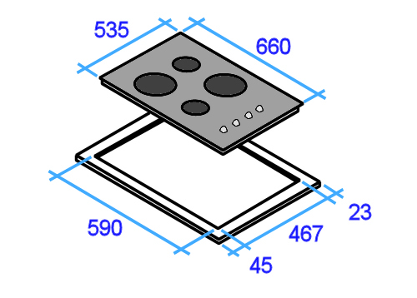
Once it’s installed, the clearances to the back and right hand side of the cooktop will be the minimum allowed under AS 4386.
The diagram at left shows the cooktop dimensions and cut-out dimensions. The white border around the cut-out represents the cooktop overlap where it sits on the bench top.

- How far in from the splashback will you draw your rear cut-out line? Mark the measurement on the 3D drawing.
- How far in from the right hand panel will you draw the right hand cut-out line? Mark the measurement on the 3D drawing.
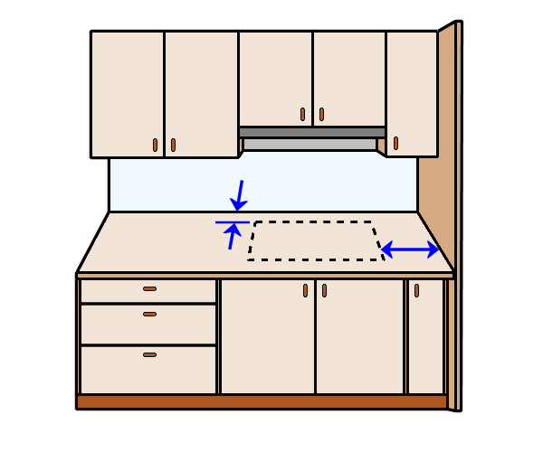
(a) mm
(b) mm

